**Abdullah Dar 21-L-7512 BSCS-6G**

**Operational Research**

**Assignment no 1**

**Question no 1:**

**Maximize the profit for the given scenario.**

**Objective Equation: Z = 2x1 + 7x2**

**Constraints: -**

**-4x1 + 12x2 <= 7**

**12x1 <= 18**

**-6x1 + 5x2 <= 6**

**2x1 - 3x2 <= 1**

**Solution:**

**X = 1.5**

**Y = 1.08333333**

**Z = 10.58333**

**Excel Screenshot:**

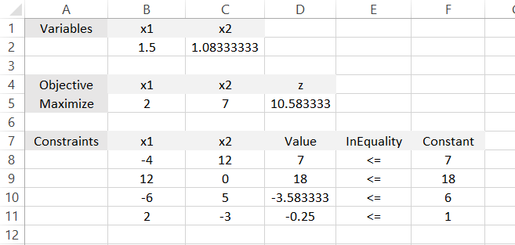

**Question no 2:**

**Maximize the sales for the given scenario.**

**Objective Equation: Z = 9x1 + 3x2**

**Constraints: -**

**2x1 + 5x2 <= 17**

**8x1 + 6x2 <= 8**

**3x1 - x2 <= 2**

**5x1 + 2x2 <= 1**

**4x1 + x2 <= 4**

**7x1 <= 14**

**Solution:**

**X = 0.2**

**Y = 0**

**Z = 1.8**

**Excel Screenshot:**

**Question no 3:**

**Question no 1 using GeoGebra.**

**Solution:**

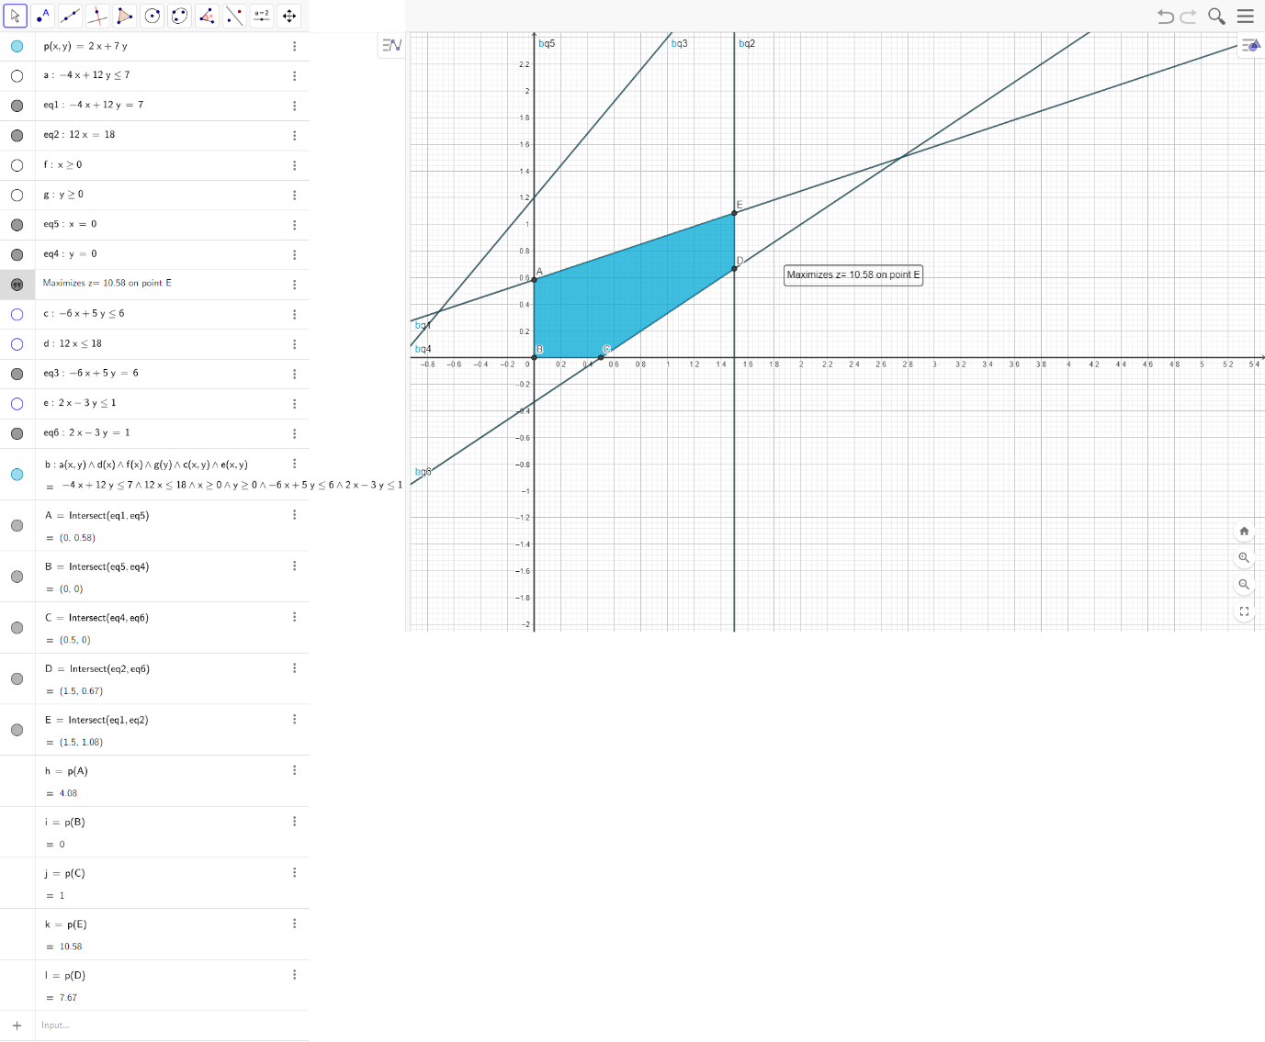

**Question no 4:**

**Question no 2 using GeoGebra.**

**Solution:**

